Crossroads International Church Dr. Rick Griffith
Title
30 March 2014 Series on Revelation Message 16 of 20
NLT 25 Minutes (AGM)
The Final Wrath
Revelation 15–16

Topic: Judgment
Subject: Why does God have the right to judge the world?
Complement: God is holy and Jesus is returning.
Purpose: The listeners will acknowledge Christ’s authority over the world and their lives
Song: Jesus is Lord
.
Homiletical Outline (Cyclical inductive form)

Introduction

Interest: Many people say that God doesn’t have the authority to judge the world.
God’s right to judge

The movie “Noah” appears Thursday but isn’t even close to the biblical story where God judges sin.
Environ-ment
Noah

Instead, Noah is the first environmentalist! He cares only for animals, not people—not even his own family!

Hundreds of snakes invade the ark—not two, as in the Bible where there were two of each “kind.”
Snakes
Ark Door

The water almost floods the ark.

What about Noah’s three sons—where did the daughter come from?
Daughter
Methuselah

Noah’s grandfather Methuselah is witch doctor.

Noah is a violent man who tries to kill his granddaughters—not godly!
Violent
Atheist

But what can you expect from the producer, who is an avowed atheist? He himself calls the film the “most unbiblical” film about the Bible!

Many refuse to believe God has the right to judge them (first 3 minutes of Ray Comfort clip at noahthemovie.com).
Ray Comfort

Need: Do you think God has the right to judge the world? Why or why not?
Need

Subject: Why does God have the right to judge the world?
• Why?

Background: Up to this point in the Tribulation, Christ has already unleashed two cycles of judgment—seven seals and seven trumpets.
Subject
Chart

Preview: Today, in the final wrath, we will see why God has the right to judge and then see how he will do it.
Preview

Text: Revelation 15 will answer the first question (“why?”) and Revelation 16 will answer the second (“how?”).
• Why?
• How?

(So, first, why does God have the authority to judge the world?)

I. God alone is holy (Rev. 15).
MP
[All of us are sinful—and thus under judgment—but only God is just enough to judge.]
Holy = Judge
Arbitrary?

The final seven plagues will finish God wrath on the earth (15:1).
1

Tribulation martyrs will proclaim God as holy and just to judge (15:2-4).
2

These victorious over the beast must have come out of the Tribulation period.
3-4

Note the repeated emphasis on God as just, holy, and righteous!

Angels will prepare seven plagues in heaven’s temple (15:5-8).

The earthly tabernacle is patterned after God’s holy heaven tabernacle.
5

The spotless white linen of the angels speaks of God’s holiness.
6

Only because God is holy could he have righteous wrath!
7

We shouldn’t see a contradiction between God’s glory and judgment!
8

(So we have answered the first of two questions— why does God have the right to judge the world? Because he alone is holy! Now for the second question: How will he do it at the end of the age?)
MPI

II. Christ will judge the earth through seven bowls before he returns (Rev. 16).
MP
[The reason angels will pour out seven bowls will be to show Christ’s sovereign authority to judge the world just before he comes back.]

Christ will command seven angels to pour out his wrath on the earth to show that this is his doing—not simply a natural calamity (16:1). This “mighty voice” is likely Christ due to his voice in 1:15 and 10:1-2…
= Christ
(4 slides)
16:1

The seven bowls of Christ’s wrath will ruin the earth just prior to his return (16:2-21).
They are parallel to the trumpet judgments in type and order—but far more severe!
Same Type (3 slides)

Ugly, painful sores will afflict Antichrist's followers (16:2).
1
2
3
Rivers
Seas
Sores

All saltwater life will die when all seas turn to blood (16:3).

All freshwater life will die when all rivers and springs turn to blood (16:4-7).

Here’s another reminder that God is just in judging.
Just

Wiersbe comments on how God’s judgment fits the crime [red quote].
Wiersbe

Unrepentant people will be burned with the sun’s fire (16:8-9).
5
4
Dark
Sunburn

Antichrist's kingdom will be plunged into darkness while the sores and burns continue but people will still refuse to repent (16:10-11).

The dried up Euphrates will allow eastern armies to cross supposedly to war against other nations at Armageddon but Satan’s real purpose will be to gather them to fight Christ (16:12-16).
China?
Euphrates
6

Many have taught that these armies all must come from China.
Many!

But, interestingly, 8 of the 10 largest armies in the world are east of Israel!

Remember the three beasts of Revelation 13? They show up again here.
Beasts

Three evils spirits will come from these beasts (16:13-14).
13-14

Once again we are warned of holiness required by Christ before his return.
15

The demons will gather the world’s armies at Megiddo (“place of troops” or “place of slaughter”) for an extended campaign (not a single battle). This prepares them for defeat by Christ in Revelation 19.
16

An earthquake will level mountains and islands accompanied by 75-pound hailstones (16:17-21).
17
7

An earthquake will destroy Babylon and every city on earth!
19b-20
18-19a
21

Hail as heavy as a talent of silver (75-125 pounds; 35-57 kg) will give people further reason to curse God—not repent!
Subject
(Why does God have the right to judge the world?)

Conclusion

God is holy and Jesus is returning (MI)!
MI

The Father must judge sin in his righteousness and the Son must cleanse this earth before coming back to set up his own kingdom (MI restated).

Today Revelation 15–16 has taught us that… (MPs repeated)
MPI
MPII

God alone is holy (Rev. 15).

Christ will judge the earth through seven bowls before he returns (Rev. 16).

Application

Do you acknowledge Christ’s authority over this world in the future?
World
You

Do you acknowledge Christ’s authority over your own life right now?

Prayer
Black

Preliminary Questions

Verses Questions

Context: What did the author record just prior to this passage?

We have just seen Satan’s activity during the Tribulation during the Revelation 12–14 parentheses (events that do not bring forth the chronology).

Now the attention turns back to God’s judgment of the earth.

Purpose: Why is this passage in the Bible?

God’s pattern throughout Scripture is to give ample warning before he unleashes his judgment.

The bowl judgments are climatic warnings just before Christ’s return to judge the unbelieving world.

Background: What historical context helps us understand this passage?

The symbol of the bowl being poured out is a common one for that which happens quickly and is irreversible.

Therefore, these judgments will take place very quickly—perhaps within a week—and will be the last, irreversible signs of God’s wrath (15:1).

Questions

In what sense do these seven plagues complete God’s wrath (15:1)? Isn’t hell a continued wrath of God? It is, but the near context concerns the three cycles of Tribulation judgments about to finish.

What is the point of the people who overcame the beast (15:2-4)? They sing that God is just in his judgment about to come (15:3-4).

How can we have a temple in heaven (15:5) when there is no temple in the eternal state (21:22 “I saw no temple in the city, for the Lord God Almighty and the Lamb are its temple”)? These speak of two different time periods.

Whose voice from the Temple commands the bowl judgments (16:1)?

“This is undoubtedly the voice of God speaking from His heavenly temple. The adjective translated “loud” (mega¿lhß) is frequently used in this chapter (v. 17 also refers to the loud voice). But the same Greek word is used in connection with intense heat (v. 9), the great river Euphrates (v. 12), the great day of God Almighty (v. 14), a severe earthquake (v. 18), the great city (v. 19), Babylon the Great (v. 19), huge hailstones (v. 21), and a terrible plague (v. 21). The judgments being poured out are greater, more severe, more intense than anything that has happened in the preceding events” (Walvoord, BKC).

However, it could well be that this voice is from Christ himself:

Christ speaks with “the voice of many waters” (1:15b).

Christ alone is worthy to enact the seal judgments (5:5).

The “mighty angel” (10:1) also has a powerful voice—which is likely Christ.

Bowls #1-4: Is the progression here significant from land to sea to freshwater to sky (16:2-9)? Yes, God will hit people from every side to make it crystal clear that this is his doing, yet these people will not repent (16:9b, 11b, 21b).

Bowl #2: Does the sea really become genuine blood (16:3)?

“It is probable that the ocean here did not chemically correspond to human blood, but that it looked like blood and had the same effect in killing everything. Just as in the second trumpet, the blood here is analogous to the first plague in Egypt (Ex. 7:20-25). As most of the earth’s surface is covered by the seas, this is a worldwide, tremendous judgment” (Walvoord, BKC).

Bowl #5: Why would God send darkness (16:10)? In reality, darkness is the world’s default mode until God spoke light into existence! He will only take away light to show people the reality of Satan’s kingdom.

Bowl #6: Who will comprise these “kings of the east” (16:12)?

Will their initial goal be to fight one another or to fight God (16:14)?

The text is clear that demons gather them to fight God, but they could do this through deception by originally seeking to fight one another or fight Israel.

BDAG notes that the word for “battle” (NLT) here can also be translated “war” (NAU):
po/lemoß, ou, oJ (s. prec. entry; Hom.+; loanw. in rabb.).
1. military conflict
a. war Hb 11:34. po/lemoi kai« aÓkoai« pole÷mwn wars and rumors of wars Mt 24:6; Mk 13:7. W. aÓkatastasi÷ai Lk 21:9. W. limo/ß 1 Cl 56:9 (Job 5:20). sumbalei√n tini ei˙ß po/lemon make war on someone Lk 14:31 (sumba¿llw 5a). poiei√n po/lemon meta¿ tinoß (s. meta¿ A2cb) Rv 11:7; 12:17; 13:7 (Da 7:21 Theod.); 19:19. AFridrichsen, Krig och fred i Nya Testamentet ’40.

b. of a single engagement battle, fight (Hom., Hes.; Diod. S. 22, 13, 5; Appian, Bell. Civ. 3, 67 §278; Polyaenus, Exc. 13, 3; 9; 3 Km 22:34; 1 Macc 4:13; 10:78; JosAs 26:5; Jos., Bell. 3, 189) paraskeua¿zesqai ei˙ß p. prepare for battle 1 Cor 14:8. Of horses (Dio Chrys. 46 [63], 4) e˚toima¿zesqai ei˙ß p. be made ready for battle Rv 9:7. tre÷cein ei˙ß p. rush into battle vs. 9. Cp. 12:7; 16:14; 20:8.
2. a state of hostility/antagonism, strife, conflict, quarrel fig. ext. of 1 (since Soph., El. 218; Pla. [e.g. Phd. 66c]; Epict. 3, 20, 18; TestJob 4:4; TestGad 5:1; ApcMos 28; Philo, Praem. 91, Gig. 51; Tat. 26, 3) of earthly and heavenly powers IEph 13:2 (opp. ei˙rh/nh).—Of the situation in Corinth 1 Cl 3:2; 46:5. Pl. (w. ma¿cai; cp. Dio Chrys. 11 [12], 78; Himerius, Or. [Ecl.] 3, 7) Js 4:1.—B. 1374. DELG s.v. pelemi÷zw II. Frisk. M-M. EDNT. TW.

Tentative Subject/Complement Statements

Text

Possible Illustrations

Ken Ham: The Unbiblical ‘Noah’ Is a Fable of a Film (28 March 2014)
http://time.com/42274/ken-ham-the-unbiblical-noah-is-a-fable-of-a-film/
Except for some of the names in the movie, like Noah, his sons’ names, and Methuselah, hardly any remnant of the Bible’s account of the Flood in Genesis 6-9 is recognizable. Yes, there is an Ark in the film that is true to the massive biblical proportions, but it did not look like a seaworthy vessel. There were many animals that came to Noah and went on board the Ark, but there were far too many creatures crammed inside and certainly many more than were needed. Also, while the extreme wickedness of man was depicted, the real sin displayed in the film was the people’s destruction of the earth. Lost within the film’s extreme environmentalist message is that the actual sins of the pre-Flood people were a rebellion against God and also man’s inhumanity to man.
Noah’s misanthropy is revealed many times in the film. For example, when the girlfriend of Noah’s son Ham is caught in a trap and is about to be overtaken by some marauders, Noah leaves the girl to die at their hands. The film’s Noah wants to totally destroy the human race and doesn’t want his sons to have children. In perhaps the most shocking part of the film, Noah plans to kill his unborn grandchild, the child of Shem’s wife, if it is a girl. As Noah values his animals on board more than people and rants about it, he becomes a psychopath. Hollywood’s Noah is not the righteous man described in Hebrews 11 and other scriptures.
Even putting aside the movie’s scene that presents evolution’s alleged progression of simple animals to humans, I noted pagan elements in “Noah.” His grandfather Methuselah is something of a witch doctor. In addition, Noah gets the idea of building the Ark after drinking a magical potion.
Ultimately, there is barely a hint of biblical fidelity in this film. It is an unbiblical, pagan film from its start. It opens with: “In the beginning there was nothing.” The Bible opens with, “In the beginning God.” That difference helps sum up the problem I have with the film. The Bible is about the true God of creation; the movie does not present the true God of the Bible

Possible Applications

Text

(Rev. 15–16) Angels prepare and pour out seven bowls of judgment to reveal Christ's sovereign authority to judge the world just before His Return.

(Ch. 15) Preparation for the bowl judgments of chapter 16 further heightens the reader's expectation for the climactic bowl judgments that immediately precede Christ's Return.

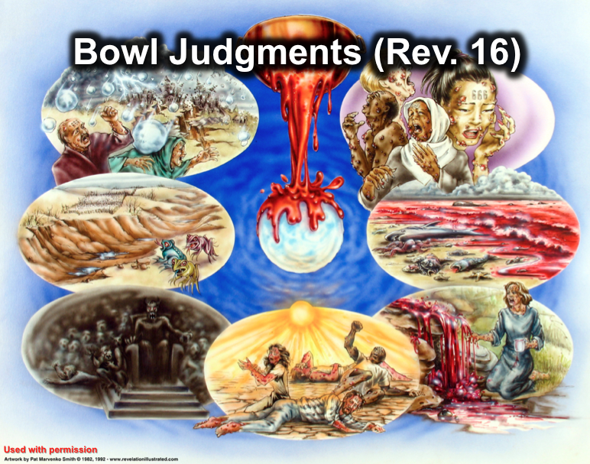

(Ch. 16) Angels pour out seven bowls of judgment to reveal Christ's sovereign authority to judge the world just before His Return.

(16:1-2) The first bowl afflicts ugly, painful sores on Antichrist's followers.

(16:3) The second bowl kills salt water marine life by turning seas to blood.

(16:4-7) The third bowl kills all fresh water marine life by turning all rivers and springs into blood.

(16:8-9) The fourth bowl burns unrepentant people with the sun’s fire.

(16:10-11) The fifth bowl plunges the Antichrist's kingdom into darkness while the sores and burns continue, but they still refuse to repent.

(16:12-16) The sixth bowl dries up the Euphrates for the crossing of the Oriental armies for war against other nations at Armageddon, but Satan's purpose will be to gather them to fight Christ.

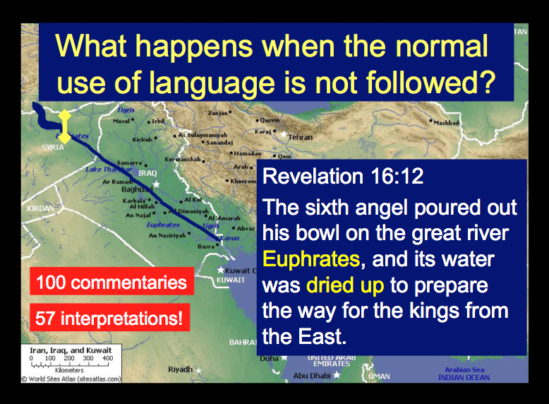

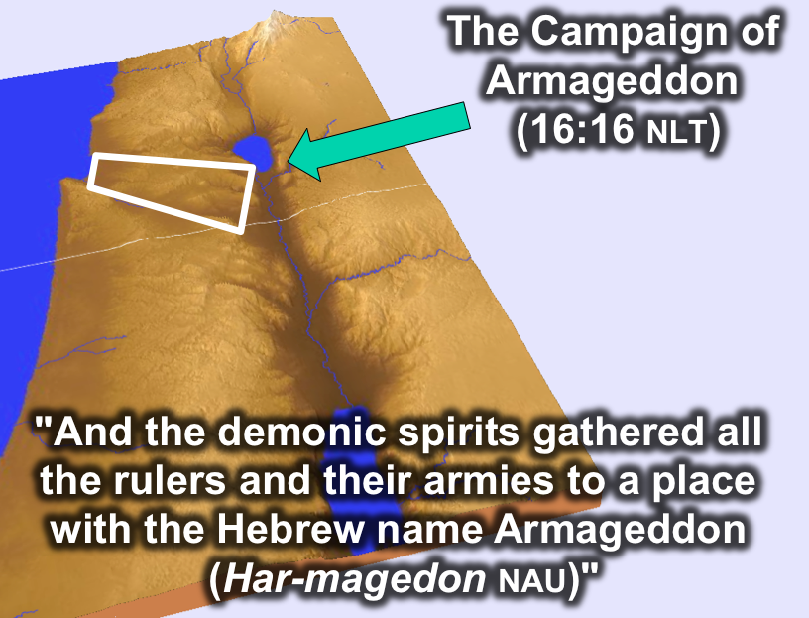

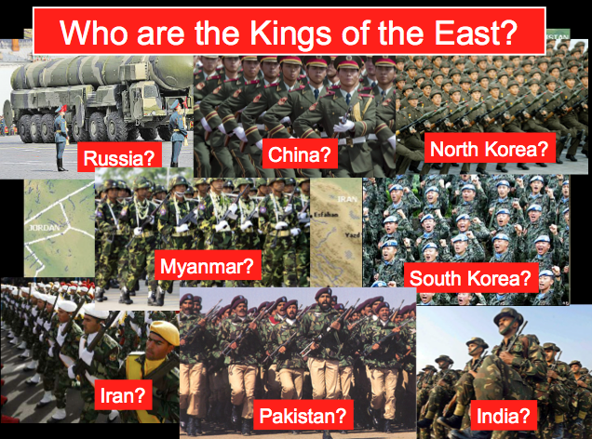

(16:17-21) The seventh bowl produces both an earthquake that levels mountains and islands, and one hundred pound hailstones.

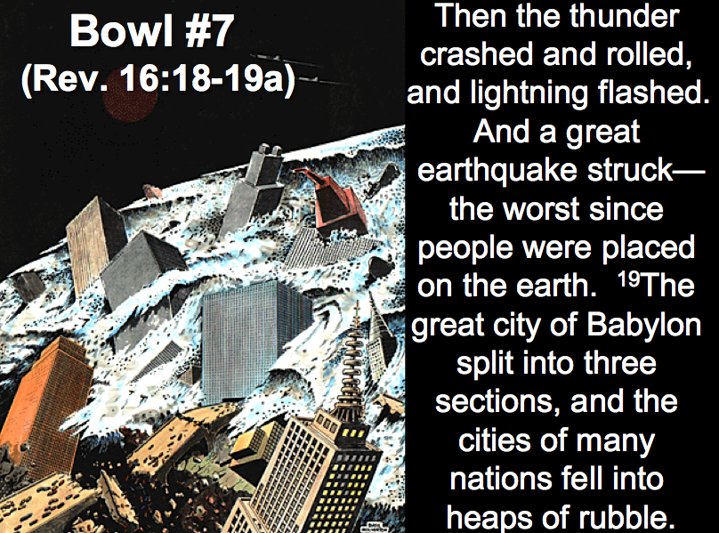

This ends the Tribulation cycle of 21 judgments and immediately precedes the return of Christ. What follows in chapters 17–18 is parenthetical with a focus on Mystery Babylon.

The Final Wrath
Revelation 15–16

Exegetical Outline (Steps 2-3)

Exegetical Idea: The reason angels will prepare and pour out seven bowls of judgment will be to reveal God as holy and Christ as the authority to judge the world just before His Return.

I. The reason God can prepare for the bowl judgments of chapter 16 is because God alone is holy and just (Rev. 15).

The final seven plagues will finish God wrath on the earth (15:1).

Tribulation martyrs will proclaim God as holy and just to judge (15:2-4).

Angels will prepare seven plagues in heaven’s temple (15:5-8).

II. The reason angels will pour out seven bowls will be to show Christ’s sovereign authority to judge the world just before his return (Rev. 16).

Christ will command seven angels to pour out his wrath on the earth to show that this is his doing—not simply a natural calamity (16:1).

The seven bowls of Christ’s wrath will ruin the earth just prior to his return (16:2-21).

Ugly, painful sores will afflict Antichrist's followers (16:2).

All saltwater life will die when all seas turn to blood (16:3).

All freshwater life will die when all rivers and springs turn to blood (16:4-7).

Unrepentant people will be burned with the sun’s fire (16:8-9).

Antichrist's kingdom will be plunged into darkness while the sores and burns continue but people will still refuse to repent (16:10-11).

The dried up Euphrates will allow eastern armies to cross supposedly to war against other nations at Armageddon but Satan’s real purpose will be to gather them to fight Christ (16:12-16).

An earthquake will level mountains and islands accompanied by 75-pound hailstones (16:17-21).

Purpose or Desired Listener Response (Step 4)
The listeners will acknowledge Christ’s authority over the world and their lives.

Homiletical Outline (Cyclical inductive form)

Introduction

Interest: Many people say that God doesn’t have the authority to judge the world.

“Noah” comes out on Thursday but isn’t even close to the biblical story where God judges sin—instead, it has an environmentalist take on the film.

Many refuse to believe God has the right to judge them (first 3 minutes of Ray Comfort clip at noahthemovie.com).

Need: Do you think God has the right to judge the world? Why or why not?

Subject: Why does God have the right to judge the world?

Background: Up to this point in the Tribulation, Christ has already unleashed two cycles of judgment.

Preview: Today, in the final wrath, we will see why God has the right to judge and then see how he will do it.

Text: Revelation 15 will answer the first question (“why?”) and Revelation 16 will answer the second (“how?”).

I. God alone is holy (Rev. 15).

The final seven plagues will finish God wrath on the earth (15:1).

Tribulation martyrs will proclaim God as holy and just to judge (15:2-4).

Angels will prepare seven plagues in heaven’s temple (15:5-8).

II. Christ will judge the earth through seven bowls before he returns (Rev. 16).

Christ will command seven angels to pour out his wrath on the earth to show that this is his doing—not simply a natural calamity (16:1).

The seven bowls of Christ’s wrath will ruin the earth just prior to his return (16:2-21).

Ugly, painful sores will afflict Antichrist's followers (16:2).

All saltwater life will die when all seas turn to blood (16:3).

All freshwater life will die when all rivers and springs turn to blood (16:4-7).

Unrepentant people will be burned with the sun’s fire (16:8-9).

Antichrist's kingdom will be plunged into darkness while the sores and burns continue but people will still refuse to repent (16:10-11).

The dried up Euphrates will allow eastern armies to cross supposedly to war against other nations at Armageddon but Satan’s real purpose will be to gather them to fight Christ (16:12-16).

An earthquake will level mountains and islands accompanied by 75-pound hailstones (16:17-21).

(Why does God have the right to judge the world?)

Conclusion

God is holy and Jesus is returning (MI)!

Main Points

Application

Do you acknowledge Christ’s authority over this world in the future?

Do you acknowledge Christ’s authority over your own life right now?

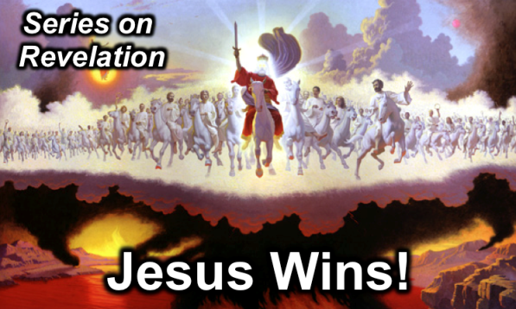
Rick Griffith
30 March 2014
Message 16 of 20

The Final Wrath
Revelation 15–16

Introduction

Interest: Many people say that God doesn’t have the authority to judge the world.

“Noah” comes out on Thursday but isn’t even close to the biblical story where God judges sin—instead, it has an environmentalist take on the film.

Many refuse to believe God has the right to judge them (Ray Comfort clip at noahthemovie.com).

___________ does God have the right to judge the world?

Today we will see why God has the right to judge (Rev. 15) and then see how he will do it (Rev. 16).

I. God alone is ___________ (Rev. 15).

The final seven plagues will finish God wrath on the earth (15:1).

Tribulation martyrs will proclaim God as holy and just to judge (15:2-4).

Angels will prepare seven plagues in heaven’s temple (15:5-8).

II. Christ will judge the earth through seven bowls before he _______________ (Rev. 16).

Christ will command seven angels to pour out his wrath on the earth to show that this is his doing—not simply a natural calamity (16:1).
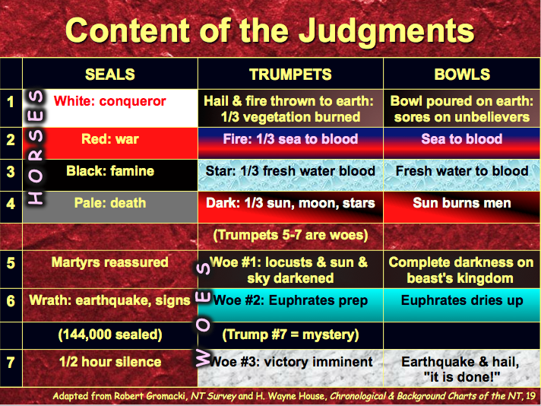

The seven bowls of Christ’s wrath will ruin the earth just prior to his return (16:2-21).

Ugly, painful sores will afflict Antichrist's followers (16:2).

All saltwater life will die when all seas turn to blood (16:3).

All freshwater life will die when all rivers and springs turn to blood (16:4-7).

*God is holy & just

Unrepentant people will be burned with the sun’s fire (16:8-9).

Antichrist's kingdom will be plunged into darkness while the sores and burns continue but people will still refuse to repent (16:10-11).

The dried up Euphrates will allow eastern armies to cross supposedly to war against other nations at Armageddon but Satan’s real purpose will be to gather them to fight Christ (16:12-16).

*We should be holy!

An earthquake will level mountains and islands accompanied by 75-pound hailstones (16:17-21).

(Why does God have the right to judge the world?)

Conclusion

God is _____________ and Jesus is _____________________ (Main Idea)!

Do you acknowledge Christ’s authority over this world in the future?

Do you acknowledge Christ’s authority over your own life right now?

Thought Questions

- Read Revelation 15–16 aloud. List God’s attributes noted in these verses and paraphrase each in your own words.

Attribute (and verse) | Paraphrase

- Why do you think people deny God’s right to judge them?

- How do you need to better see Christ’s authority in your own life?

